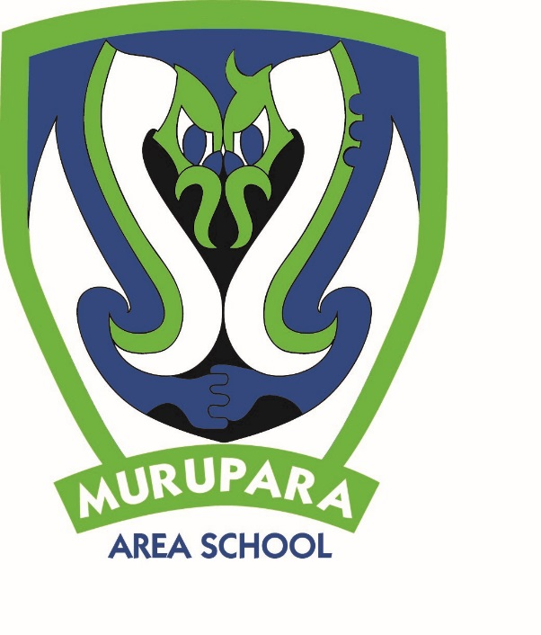

**Newsletter: 7th June 2019, Week 6, Term 2.**

**KEY DATES**

**JUNE**

10 Tough Guy and Gal – Hamilton

10-4 Scholastic Book Fair

11 Kahui Ako hui – **school closes at 2.30pm**

12 Field Days - Hamilton

14 **Reports issued**

16-17 Pūhoro pou herenga

19 Parent teacher evening 4 – 6pm

24 **TEACHERS ONLY DAY – school closed for instruction**

25 BOP Cross Country Champs - Tauranga

26 Quick Rip Rugby

27 Rangipō AAA Trip

29 BOT hui

**JULY**

5 Whakaruruhau hui

5 Last day of Term 2

22 First day of Term 3

**AUGUST**

1 Vaccinations Y7 BOOSTRIX

2 Whakaruruhau hui

4-5 Pūhoro pou herenga

9 Tauranga Careers Expo

**Yr 7 & 8 Invitational Basketball Tournament – Friday 31st May 2019**

*PRINCIPAL’S PANUI*

**Kia ora koutou katoa,**

What a busy term this has been. I have loved seeing our tamariki getting involved in the wide variety of sporting and academic opportunities here at MAS. I would like to thank all the parents and extended whānau who give up their time to support our students, whether you are coaching, managing, driving or supporting on the sidelines. We appreciate you!

We have been working on different ways to keep whānau informed of the events and successes of our tamariki and the kura. Your child will be coming home with your personal username and password so you can access our Parent Portal. You can go to the parent portal from our school website, or you can download for free our school app from the Apple store or Google Play. The Parent Portal will allow you to check our school calendar, look at your child’s attendance and their academic progress and see your school account. All of these things are live and up to date. We will be running a couple of afternoon or early evening sessions for whānau over the next few weeks to help you learn how to use the portal. As part of this process, we also need to update our student contact details, including email addresses, and we ask for your help with this.

We are strengthening ties with our Kahui Ako schools across Murupara, Edgecumbe and Kawerau. Our Teachers will be meeting together on TUESDAY 11 JUNE in Kawerau, so to help us arrive on time we will be **closing the school at 2:30pm**. These meetings are an invaluable time for our staff to share ideas with other teachers. Having a vibrant teaching and learning programme at Murupara Area School is our focus and these Kahui Ako Hui help us to achieve this goal.

Murupara Area School will also be having a **Teacher Only Day** on MONDAY 24TH JUNE. This is for further Professional Development for our staff and is the only day that our facilitator is available. It does mean that the school will be **CLOSED FOR INSTRUCTION** and students will need to stay at home that day as there is no school.

It is fantastic to see our tamariki achieving at MAS, showing our school values of Integrity, Respect and Aroha on the sports field and academically. You’re warmly invited to come to the Principals Assembly every second week. This is where we recognise our amazing tamariki and we would love to have you join us. Don’t forget to come to the parent teacher evening on the 19th.

Nga mihi

**

Dr Angela Sharples

Principal

**SPORTS REPORT**

**MOTOCROSS**

On Friday 7th June 2019 Tuesday Briscoe will compete in the 2019 Trident Interschool motocross event in Awakaponga. All the best Tuesday!! (Please note this sport is not offered at MAS)

**RUGBY**

Round 2 for the under 16 team starts on in 2 weeks. Days and times are to be confirmed but at present are:

Game 1: Friday 14/06/19 3.30pm vs Tarawera AWAY

Game 2: Saturday 22/06/19 12noon vs Tauhara HOME

Game 3: Friday 28/06/19 3.30pm vs Papamoa HOME

Game 4: Thursday 25/07/19 3.30pm vs Whakatane AWAY

Game 5: 03/08/19 BYE

Semis: 10/08/19 TBC pending results

Finals: 17/08/19 TBC pending results

**BASKETBALL**

**Yr 7+8 Boys**Wednesday 29/05/19 vs RIS Green 81/85 loss – POD Ben Tereroa

Wednesday 05/06/19 vs RIS Dennis 53/12 loss – POD Rawiri

**Yr 7+8 Girls**

Wednesday 29/05/19 vs JPC Girls – WIN – POD Shanika Howden

Wednesday 05/06/19 vs Ruamata Raukatauri – score unknown/loss

**Junior Boys**

Thursday 30/05/19 vs JPC Razzle Dazzle – 54/66 loss – POD Anthony White

Thursday 06/06/19 vs RBHS GSW

**Senior Girls**

Thursday 30/05/19 vs RGHS 12s- WON by defualt – POD Eden Te Aho

Thursday 06/06/19 vs RGHS JA Maroon

**Senior Boys**

Thursday 30/05/19 vs RBHS Hostel Airballers – POD Legend Moses

Thursday 06/06/19 vs JPC Snr B

Year 7 + 8 Invitational Basketball Tournament Friday 31 May 2019

Sportsdrome – Rotorua. They had 3 games with 1 win and 2 losses. POD Willliam Merriman. It was a great day out and the boys played well. A massive thank you their coach, Courtney-Anne Anderson, for giving up her time to take the boys in.

**NETBALL**

29.05.19 Murupara Area School 24 v RLHS Senior Blue 20

05.06.19 Murupara Area School v WHHS Senior Gold - rained off.

**CROSS COUNTRY**

On Tuesday 4th June the Te Urewera Cluster Cross Country event was held at Aniwhenua. The following students have made it through to the BOP Inter-School Cross Country Champs on Tuesday 25th June at Kaharoa School.

8yr old girls –Becky Kirk and Dilemma Rolleston

8yr old boys – Tuterangi Te Are

9yr old girls – Jazmyn Rua

10yr old girls – Leiella Te Are

10yr old boys – Kenana Rua

11yr old boys – Devron Roberts-Aramoana

12yr+ old girls – Bridget White and Sapphire Rutene

12yr+ old boys - Anzac Hanuera-Matekuare

**MOUNTAIN BIKING ASSESSMENT**

For the past 2 Thursdays, students from the MAS Academy have been working through their Advanced Mountain Biking Assessments at the Redwoods in Rotorua alongside Matua Meihana. Lots of laughs, falls and crashes but they all passed their L2 credits successfully. Making good use of school resources out and about.

**FRIDAY KAI DAY**

Whaea Suzanne and K2 baked Chatham Island no fail bread rolls. Well done guys they look amazing.

**BASKETBALL REFFEREE COURSE**

On Thursday 6th June, a handful of students were given the opportunity to do the Referees’ Education Course run by Sue Pene from Rotorua Basketball. Not only does this give them a certificate but also saves our teams money by being able to ref games. It also provides an opportunity for employment as a referee. Tau ke tamariki ma.

