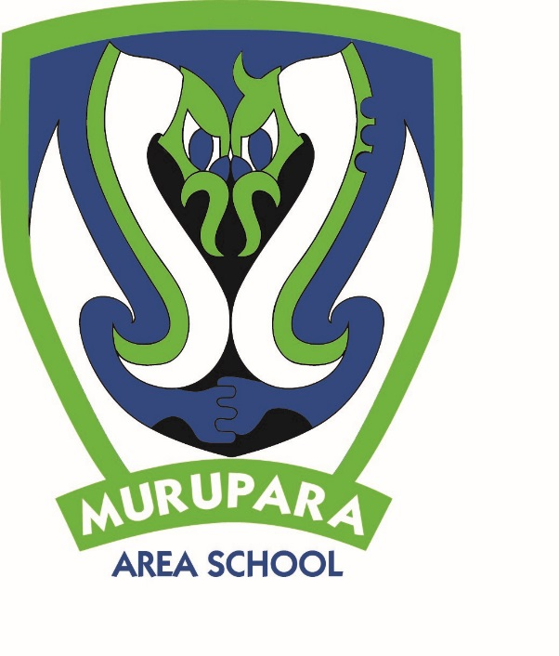

**KEY DATES**

**MAY**

– 31 May   
Dental Clinic Unit – Onsite

28 Health curriculum community consultation, 4-6pm in the staffroom

29 **TEACHERS STRIKE – School CLOSED**

31 Toi Ohomai open day

31 New Board of Trustees take office

31 Year 7 & 8 invitational Basketball Tournament – Boys team entered

**JUNE**

3 Queens Birthday

4 Te Urewera Cluster Cross Country – Lake Aniwhenua

7 Whakaruruhau meeting

14 **Reports issued**

16-17 Pūhoro pou herenga

17 BOT hui

19 Parent teacher evening 4 – 6pm

25 BOP Cross Country Champs - Tauranga

26 Quick Rip Rugby

**JULY**

5 Whakaruruhau hui

5 Last day of Term 2

22 First day of Term 3

**Newsletter: 24th May 2019, Week 4, Term 2.**

*PRINCIPAL’S PANUI*

**Kia ora koutou katoa,**

School will be **CLOSED for instruction** on Wednesday 29th May 2019 for the teacher’s strike. A notice from your Board of Trustees has gone home today and been put up on our Facebook page. We understand that closing the school can be really difficult for whānau and your Board thought very carefully about making this decision. The safety of our tamariki is the most important thing and we don’t have enough non-striking staff to provide a quality teaching programme for the day or safely supervise our tamariki. We are sorry for the inconvenience. Please don’t hesitate to give me a call if you have any questions or concerns about the strike.

Don’t forget to sign up for the Connected Murupara programme if you would like free internet access for learning at home. It is a great opportunity to access broadband internet via the school’s connection and we are leading the way in community digital access with our first households being connected next week. Ros Sharp can answer all your questions if you are interested.

Reports will be issued on 14th June and there is a parent teacher evening on Wednesday 19th of June. I hope you will take this opportunity to discuss your child’s learning with their teacher.

Winter sports are well underway and there is a great sports report overleaf. Participation in sport and physical activity has a positive impact on physical health. Regular physical activity is essential for children as they grow into their body. Exercise, of any variety, helps prevent obesity and high blood pressure and contributes to building and maintaining healthy bones, muscles and joints. And, because participation in sport as a child is strongly correlated with the maintenance of regular physical activity as an adult, the cumulative effect of playing sports as a child can significantly influence overall health over a lifetime. Team sports are particularly valuable for teaching kids’ social skills. Not only do children learn to interact effectively with teammates, but they will necessarily learn to respect opponents and behave graciously in victory or defeat. There is a myriad of lessons to be learnt in leadership, friendship, and sportsmanship that will help them throughout their personal and professional lives. Sports participation also has a positive impact of learning because physical activity helps improve the duration and intensity of concentration. So, we encourage all our tamariki to get involved in sports at school and thank you to our team of staff, coaches and other volunteers who work so hard to make sure our tamariki have every possible opportunity to get physically active.

Nga mihi

**

Dr Angela Sharples

**INDIGENOUS NATIVE PLANTING COMMUNITY DAY** – 15th May 2019

**INDIGENOUS NATIVE PLANTING COMMUNITY DAY.  
PEKEPEKE PROJECT SITE.  
RANGI KANI PARK.**

Nga mihi nui ki a koutou katoa,

Last week on Wednesday 15th May, Murupara Area School staff and students’ from Years 2 – 13 participated in a significant community event, the beginning of a planting project at Kani Rangi Park.

The event unveiled the “Pekepeke Project Pou Whenua” a restoration project initiated by Te Rūnanga o Ngāti Manawa aimed to link, expand, and enhance existing and established areas of indigenous vegetation along the Rangitaiki river for recreational use. The project also aims to restore culturally significant sites along the river. Those in attendance were local Kaumatua, schools, kohanga Reo, kindergarten, community members and Te Rūnanga o Ngāti Manawa. The special guests were Associate Environment Minister Eugenie Sage and the Mayor of Whakatane, Tony Bonne.

Associate Environment Minister Eugenie Sage unveiled the “Pekepeke Project Pou Whenua” with the eager assistance of some of our very own students, this was a special moment. The Minister also announced that the Government will be funding $271,824 towards the overall restoration project, a very positive outcome for our community.

Following the unveiling of the “Pekepeke Project Pou Whenua” our tamariki and those in attendance started planting. It was a wonderful sight to see and a great community event to be a part of.

Our children were very well behaved and thoroughly enjoyed the experience, they were also very pleased to share in a delicious sausage sizzle provided by Te Rūnanga o Ngāti Manawa.

The day was a huge success and an invaluable learning experience for our tamariki. Raising environmental awareness and encouraging community participation in a fantastic environmental initiative.

Ngā Mihi , Whaea Weka Kirk

**SPORTS REPORT**

**RUGBY**

Final game of the round this Friday, 24 May at 3.30pm MAS vs Whakatane (@ Murupara Rugby Club - Ngati Manawa Road)

**TAI MITCHELL RUGBY**

Congratulations to the following boys who have made it into the 2019 Galatea Tai Mitchell squad:

Edward TeAho, Tamati Mapu, Neville Tapsell, Cyrus Penetana, Anzac Matekuare, Rawiri Rua, Hohepa Howden, Temepara Hanuera, Ben Tereroa and Hugh Macpherson.

**BASKETBALL**

After a 2 week break due to prior venue bookings, the teams are back into action.

Wednesday nights – Yr 7 & 8 Girls and Boys teams.

Thursday night – 3 x Secondary teams.

On Friday the 31st May, the Year 7 & 8 Boys team will compete in the Y7 & Y8 Invitational Tournament in Rotorua. Their coach, Courtney-Anne Anderson, is excited to be able to take the team in to compete.

**NETBALL.**

Last Wednesday 15th May the girls had their first game for the season, and they had a convincing 35 – 12 win. This week they faced Ngati Rongomai and had another good win.

**CROSS COUNTRY**

On Wednesday 22nd May, all 8-12 year old students were invited to participate in this years school cross country event held at Rangi Kani Park. The age of the student is taken from day 1 of Term 2 (29th April). The distances ran were from 1km (8yr olds) – 3km (12 year olds). The top 2/3 from each section will represent Murupara Area School at the Te Urewera Cluster on the 4th June. Those students are:

8yr old girls – River Morunga, Becky Kirk and Dilemma Rolleston

8yr old boys – Tuterangi Te Are, Pounamu Higgins and Butler Toko

9yr old girls – Jazmyn Rua and Tanira Cairns

9yr old boys – Manawai-Tia Sillick and Ereatana Heurea-Williams

10yr old girls – Leiella Te Are and Perseus Te Rupe

10yr old boys – Kenana Rua and Retia Hunt-Winitana

11yr old girls – Meheyla Delemere and Eliqua Te Rupe

11yr old boys – Hohepa Howden and Devron Roberts-Aramoana

12yr+ old girls – Bridget White, Paris-Jade Morunga, Sapphire Rutene and Hema Hiko

12yr+ old boys - Anzac Hanuera-Matekuare, Tyshaun Delamere and Rawiri Rua

**FELL CUP & IVY MERRIMAN TROPHY**

The results are in (via phone conversation from the organising school) and we won!!

