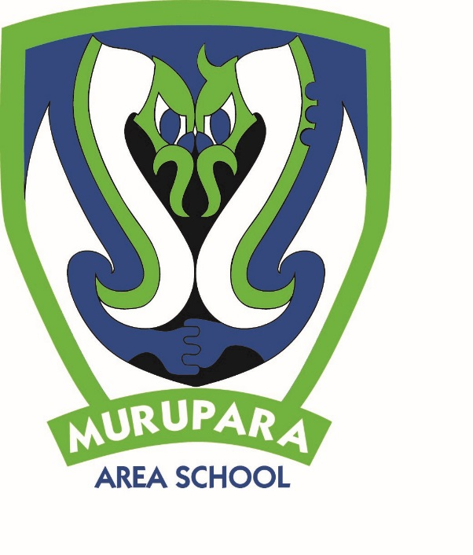

**Newsletter: 15th May 2019, Week 3, Term 2.**

**KEY DATES**

**MAY**

– 31 May   
Dental Clinic Unit – Onsite

15 Indigenous native planting community day

17 Pink shirt day – anti-bullying day

17 NZDF careers visit (Years 11-13)

22 Year 4 – 8 Cross Country

24 Nominations for Board of Trustees **CLOSE AT NOON**

28 Health curriculum community consultation, 4-6pm in the staffroom

29 Voting papers for BOT election sent out by today if required

31 Toi Ohomai open day

31 Year 7 & 8 invitational Basketball Tournament

**JUNE**

3 Queens Birthday

4 Te Urewera Cluster Cross Country – Lake Aniwhenua

5 CBOP Rippa Rugby – Rotorua

7 Board of Trustees **ELECTION DAY**

7 Whakaruruhau meeting

12 BOP Rippa Rugby Champs

13 Votes in Board of Trustees election counted

14 Board of Trustees elected trustees take office

16-17 Pūhoro pou herenga

17 BOT hui

25 BOP Cross Country Champs

26 Quick Rip Rugby

**JULY**

5 Whakaruruhau hui

5 Last day of Term 2

22 First day of Term 3

*PRINCIPAL’S PANUI*

**Kia ora koutou katoa,**

I really want to make sure that everyone knows about Connected Murupara. Our aim is to make learning accessible ‘anywhere, anytime, and at any pace’ by providing free connection to the internet at home for school students and close the digital divide so that our tamariki have access to the raft of learning opportunities that WiFi and digital tools enable. This will provide unlimited internet access at home for school students at no cost to the whānau. Come and see Ros at the school if you are interested in being connected. At our community hui last Thursday, we gave away two Acer flip chromebooks worth $600 each to celebrate. Congratulations to Miro Hokianga and Calvin who won the chromebook donated by our Deputy Mayor, Judy Turner; and Marion Jacobs from Kura Pounamu who won the chromebook donated by MAS.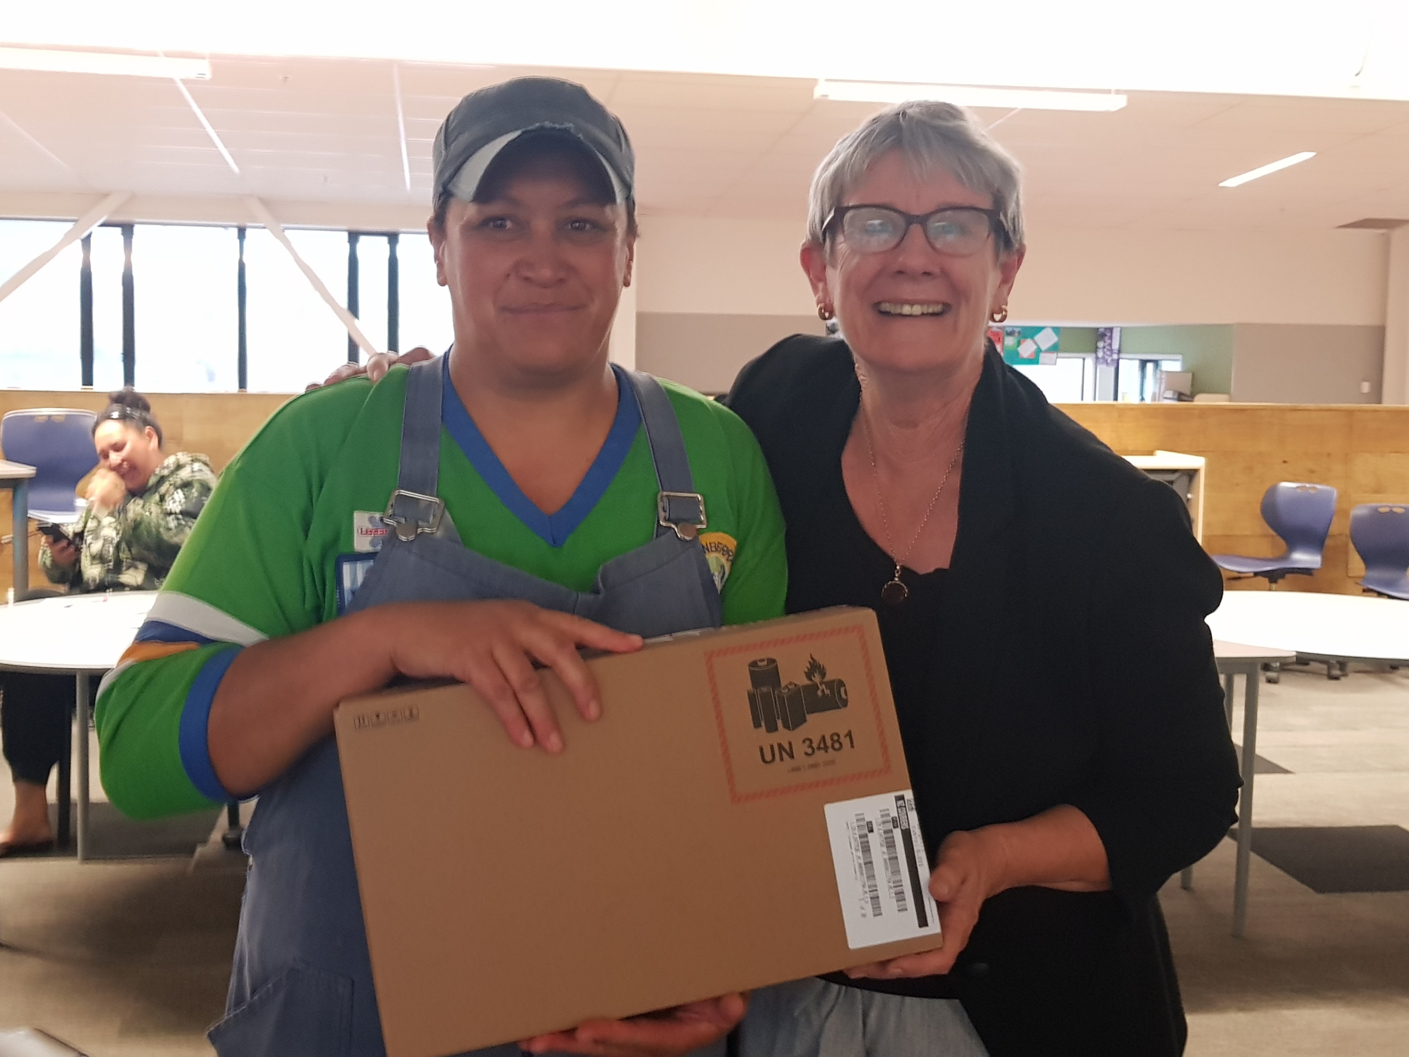

Te Aka Toitū was set up two years ago by six local Principal’s and together with our sponsors and partners have made this possible. Murupara Area School is the first to get our community free CPE connections to the school’s internet up and running. Thanks to: Bay Trust, Eastern Bay Energy Trust, First Credit Union, Internet NZ, Ministry of Education, Murupara Community Board, N4L, Ngahuinga Motumako Trust, Tangiharuru Apa Trust, Te Rūnanga O Ngāti Manawa, Variety, WiFi Connect.

There is a community consultation hui on Tuesday 28th May – we will be asking for your thoughts on our health curriculum, what do you think we should be covering in our health classes?

Nominations are now open! It’s time to step forward for Murupara Area School. Nomination forms have been sent out so please consider standing. Boards of trustees play an important role in our school community creating a better future for our tamariki.

At the start of this term we welcomed two new staff; Weka Kirk joins our Nīoreore team and Mrs Kura Hingston joins us as the senior English teacher and specialist classroom teacher. Our Rangipō Hub Leader, Mrs Charlotte Kutia is now teaching Hospitality.

Nga mihi

**

Dr Angela Sharples

**FELL CUP, REPOROA COLLEGE, 8th May 2019**

**MESSAGE FROM THE STAFF**  
Tēnā koutou katoa  
The school has supplies of head lice treatment and sanitary items for students. Please let your child know that they can approach any staff member they feel comfortable with to get supplies. There is also stock of KidsCan jackets and shoes available ready for the winter months ahead.

**SPORTS REPORT**

RUGBY

After a lot of ups, downs, and turn arounds, we have a senior rugby team. The team is competing in the Central Bay Under 16s. Although the team has students over the age limit, those students have been given dispensation to play so our younger ones have the opportunity to play. If the team are doing well then BOP Rugby may consider the team going up to the 2nd 15s. Thanks to Regan Merriman for coaching this team. Game 1 was a home game on Saturday 4th May and the boys had a convincing win. Confirmed game times and venues are:

Fri 17/05 3.30pm vs Papamoa (@ Papamoa College)   
Fri 24/05 3.30pm vs Whakatane (@ Murupara Rugby Club - Ngati Manawa Road)

BASKETBALL

This year Murupara Area School have 5 teams representing MAS in the Rotorua league. Year 7 & 8 Girls and Year 7 & 8 Boys teams play on a Wednesday evening.

Secondary Junior Boys, Senior Boys and Senior Girls teams play on a Thursday evening. Good luck for your season!

On the 31st May, the Year 7 & 8 Boys team will compete in the Y7 & Y8 Invitation Tournament which will be held in Rotorua. Their coach, Courtney-Anne Anderson, is excited to be able to take the team in.

NETBALL.

This year Murupara Area School have only 1 team competing in the Rotorua competition. They play on a Wednesday evening in Rotorua. The team are in the secondary school league and our team consists of Year 8 – 10 girls.

MINI MARATHON

Last Friday, 17 students attended the annual Mini Marathon in Rotorua. There are no placings at the event, but they have awesome spot prizes. 4 students picked up random spot prizes. All students ran awesomely and the behaviour was exceptional. We were very proud of them.

FELL CUP & IVY MERRIMAN TROPHY

Last Wednesday 72 students from Year 3-8 travelled to Reporoa to compete for this years Fell Cup (rugby) and Ivy Merriman Trophy (netball). A big thank you to all participating students for playing hard and their awesome behaviour and to our staff for their encouraging words and giving their time for training in the lead up to the event. We also thank the parents that drove and coached on the day and those that travelled over to support our tamariki. Thanks to the host school, Reporoa College, for putting on a fantastic day, and a special mention to two of our Service Academy boys that trained the Yr 7 & 8 Rugby team, attended the event and managed the team for the whole day. It was great to see the respect with which the two boys were held. Thank you Pita and Tuhoe.

We haven’t received any results yet but will up date in the next newsletter.

Murupara Area School was well represented on and off the court/field.

**Kāpiti Island Cultural Camp**

Pita and Tuhoe Rurehe spent 5 days on Kāpiti Island for a Cultural Camp, which is a Gateway programme run by ServiceIQ. In total there were 17 students that attended this event which was a first for Kāpiti Island to host one of these Cultural Camps. Other Camps were also being held at the same time at Waiheke Island and Waitomo.

Once students were registered, given the house rules, partook of the whakawhanaungatanga and karakia, students were then boarded on to the MV Te Aihe vessel and they headed off for their cultural experience.

Not only did Pita and Tuhoe represent MAS they were also there representing the Service Academy. Dressed in their number ones, they were certainly looking sharp on the day.

While on the Island, students learnt the history, whakapapa and local stories and tikanga/kawa of Ngāti Toa. With fingers crossed, they are hoping to return next year.

Well done boys, it was certainly a pleasure to be a part of this experience with you, and for the record, this trip earned them 20 credits.

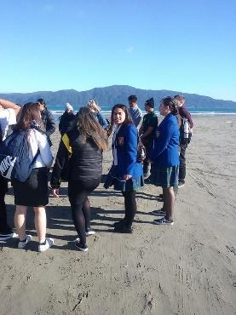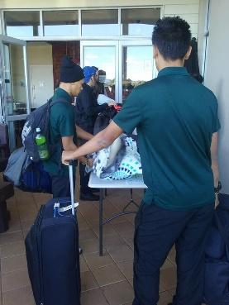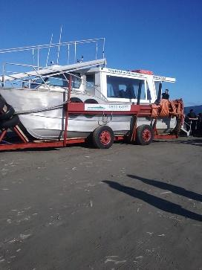

No reira, noho ora mai

Ripeka Hawkins

Trades and Gateway Coordinator

Murupara Area School